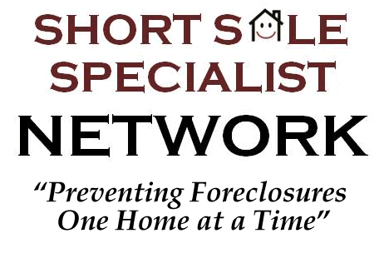
Insert your personal or company info here….
BENEFITS OF A SHORT SALE VS. FORECLOSURE
To help understand the consequences of a foreclosure please read below.
Issue | Short Sale | Foreclosure
Credit Score | A short sale itself will minimally affect your credit score, usually around 50 points. Late payments usually have the largest negative impact on your credit score from a short sale and can average 30 points or more each. | Your credit score could be lowered 300+ points and will stay on your record for 10 years!
Credit History | There is not a credit reporting item for a short sale. Upon sale, your mortgage company will typically report the short sale as ‘Paid’, ‘Settled in full’, or ‘Paid as Negotiated’ on your report. | A foreclosure will remain on your credit for 10 years and is permanent in the public records of your county.
Current Employment | A short sale is not an actual item on your credit report and typically will NOT affect your employment. | Your employer has the right and many times will actively check your credit if you are in sensitive positions. Sometimes a foreclosure is grounds for immediate re-assignment or termination.
Future Employment | A short sale is not an actual item on your credit report and typically will NOT affect future employment. | Employers do check your credit history for many job applicants. A foreclosure one of the most negative items you can have on your credit and may affect future employment.
Future Loan with a Mortgage Co. | You do not have to declare to future mortgage companies that you previously performed a short sale | On the federally mandated standard loan application form 1003 you will be required to answer ‘YES’ to the question ‘Have you had property foreclosed upon or given title or deed in lieu thereof in the past 7 years?’ Answering ‘yes’ affects the interest rate you will receive
Future Fannie Mae Loan – Primary Residence | After a successful short sale you can be eligible for a Fannie Mae backed loan after only 2 years | After a foreclosure you will be ineligible for a Fannie Mae backed loan for a minimum of 5 years
Future Fannie Mar Loan – Non-Primary | After a successful short sale you can be eligible for a Fannie Mae backed loan after only 2 years on non-primary residences | After a foreclosure you will be ineligible for a Fannie Mae backed investment loan for a minimum of 7 years
Deficiency Judgment | It is typical for the lender to give up the right to pursue a deficiency judgment against the borrower. This is stated in approval letters, and not legal to collect in many states. | The bank has the right to pursue the deficiency judgment in all foreclosures (except in states where there is no deficiency)
Deficiency Amount | A short sale home is sold at or near market value and in most cases is a greater value than a foreclosure sale which results in a lower deficiency. This deficiency is typically forgiven. Helping to cut your lenders loss as well is also the ethical thing to do. | If the home does not sale at a foreclosure auction it will have to go through the bank REO system. This will result in a longer time to sell and potentially a higher deficiency judgment for the homeowner.

Copyright First Coast Realty Associates 2010

