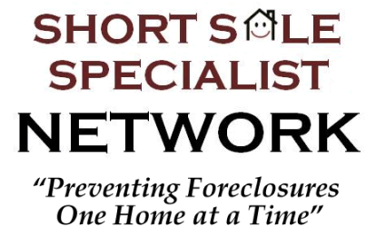
Insert your personal or company information here…

Short Sale Hardship Qualification Questions with Sellers
Used as a guide when initially speaking with a Seller to determine whether they will qualify with their lender for the short sale. Not all questions will pertain to the Seller’s situation.
Have you received a foreclosure notice or been served foreclosure papers? Has a sale date been set?

Are you currently behind on payments? If so, how many months?

What has changed for you financially since you purchased the home?

Are you currently employed? Has there been a curtailment in income or change in employment?

Have you been required to move due to a change in employment?

Are you currently going through a divorce or separation? Are you two amicable?

Is there a medical issue creating a hardship? If so, is the medical condition creating additional bills or preventing you from working?

Do you have a large amount of debt separate from your home? Has this increased since you purchased the home?

Are you currently living in the home?

Do you own any other properties, and are they producing any rental income?

Have you been in contact with your lenders regarding a short sale? If so, what did they tell you and have they sent you a short sale packet?

Have you recently applied for a loan modification? If so, what was your result or experience?

How many loans are on the property and who are the lenders? Is there mortgage insurance (PMI)?

How much do you currently owe on the property?

Based strictly on your earnings and the debt you have, do you feel like you would qualify for the loan today?

Could you afford the home if your lender dropped the payment significantly?

Is your motive to sell the home or do you wish to keep it?

Copyright First Coast Realty Associates 2010

